4.5 Dilations HW
Item at position 1
1 1 point
Quadrilateral ABCD with vertices A(-4, 1), B(-2, 3), C(0, -2), and D(-5, -2): k = 3.
Solution
Initial Coordinates: A(-4, 1), B(-2, 3), C(0, -2), D(-5, -2)
After dilation: 3(A, B, C, D)
3(-4, 1), 3(-2, 3), 3(0, -2), 3(-5, -2)
Dilated Coordinates:
A’ (-12, 3)
B’ (-6, 9)
C’ (0, -6)
D’ (-15, -6)
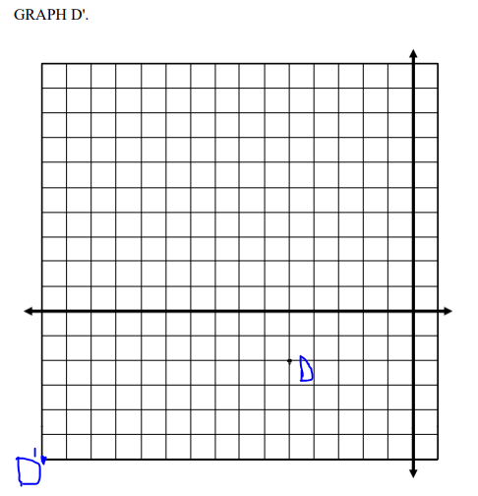
Item at position 2
2
3 points Triangle LMN with vertices L(2, -8), M(12, 8),and N(14, -4) : k = 1/2.
Solution
K(LMN), i.e. ½ (2, -8), ½ (12, 8), ½ (14, -4)
L'(1, -4).
M'(6, 4).
N'(7, -2)

Item at position 3
3
1 point
Rectangle PQRS with vertices P(5, 15), Q(15, 15), R(15, 10), and S(5, 10): k = 4/5
Solution
Coordinate R = (15, 10)
Scalar factor = 4/5
k*(R)
R’ = (4/5*15, 4/5*10)
R’ = (12, 8)
R’ (12, 8)
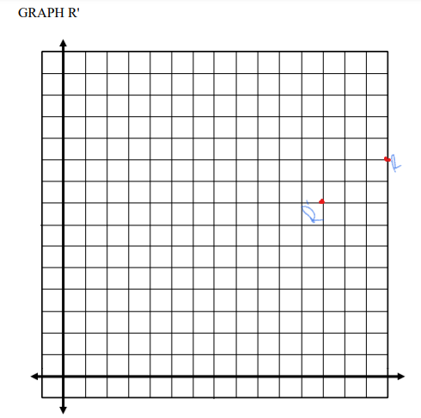
Item at position 4
4
4 points
Rhombus WXYZ with vertices W(2, -4),X(6, -2), Y(10, -4), and Z (6,-6) : k = 3/2
K (WXYZ)
3/2 {W(2, -4),X(6, -2), Y(10, -4), and Z (6,-6)}
W'(3, -6).
X'(9, -3).
Y'(15, -6).
Z'(9. -9)
Item at position 5
5
1 point
Graph D' of the quadrilateral below using a scale factor of k = 1/3.
Solution
D coordinates (15, -15)
D’ coordinates (1/3*15, 1/3*-15)
D’ (5, -5)
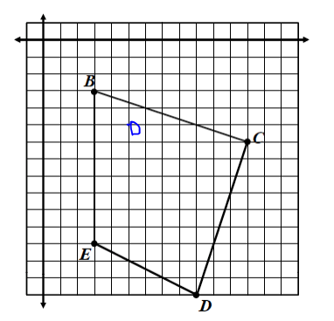
Item at position 6
6
1 point
Graph Z' of the triangle below using a scale factor of k = ¾
Solution:
Z (-12,-12)
Z’ (3/4*-12, 3/4*-12)
Z’ (-9, -9)
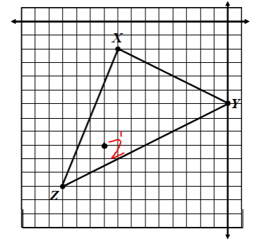

Item at position 7
7
1 point
Identify the scale factor used to graph the image below.
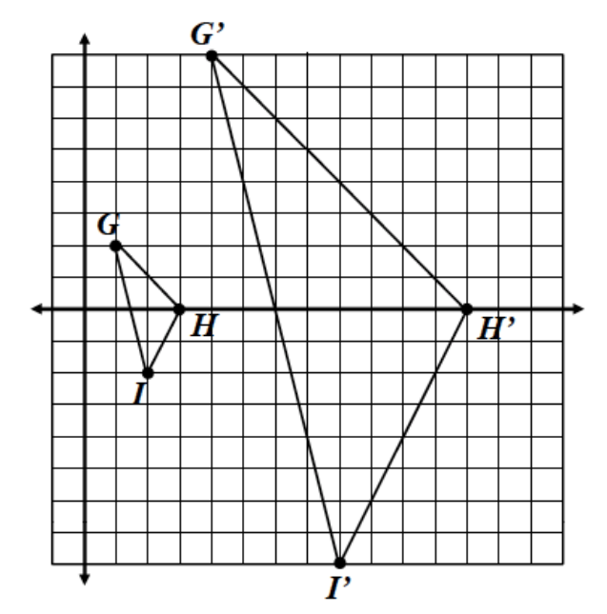
Solution:
Let’s consider point H (3, 0) and its transformation H’ (12, 0)
We’ll have 12/3 = 4
K = 4
Similarly, we can take points I (2, -2) and I’ (8, -8)
8/2 or -8/-2 = 4
K = 4

Item at position 8
8
1 point
Identify the scale factor used to graph the image below.
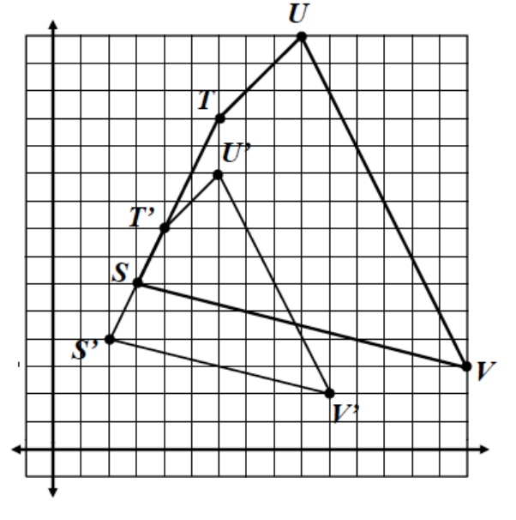
Solution:
We consider, one point from the initial figure and then the other point where it has been dilated or transformed to.
In this case, I choose point S(3, 6) and S’(2, 4)
K = 2/3 or 4/6
K = 1. 5

